 | 12.3.1 Editors - Geometry Nodes Editor - Sidebar - Group tab
Table of content
Group tab - Introduction 3
Group Properties Panel 3
Name 3
Description 3
Color Tag 3
Node Width 3
Set default group node width 3
Usage subpanel 4
Modifier 4
Tool 4
Group Sockets Panel 4
Group Socket List 4
List 4
Name 4
New Item 4
Input 4
Output 4
Panel 4
Panel Boolean 5
Duplicate Item 5
Remove Item 5
Move Item Up/Down 5
Inputs 5
Outputs 5
Type 5
Group Sockets Panel - Panel socket settings 5
Closed by default 6
Panel Toggle 6
Default 6
Hide in Modifier 6
Single Value 6
Group Sockets Panel - Input socket settings 6
Description 6
Default Attribute 6
Subtype 6
Default 7
Min 7
Max 7
Hide Value 7
Hide in Modifier 7
Single Value 7
Group Sockets Panel - Output socket settings 7
Description 7
Attribute Domain 7
Default Attribute 8
Subtype 8
Default 8
Min 8
Max 8
Hide Value 8

Group tab - Introduction
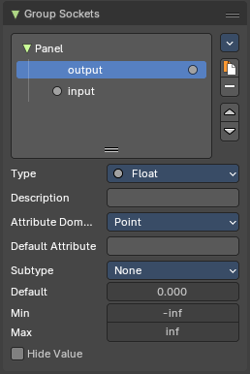
The Shader sidebar Group tab at the right side contains options and settings for node groups and socket input and output properties.

Group Properties Panel

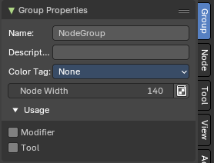
Name
Change the name of the current node group. Type in a new name and hit enter.

Description
Change the description of the current node group. Type in a new name and hit enter.

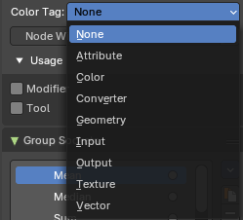
Color Tag
Changes the header color of the current node group.
Color Tag Types:
- Color
- Converter
- Input
- Output
- Script
- Shader
- Texture
- Vector

Node Width
The width for newly created node groups. Value can range between 40 and 700 px.

Set default group node width
Sets the width based of the parent node group in the current context.

Usage subpanel

Modifier
The node group is used as a geometry modifier. This setting is only relevant for marked nodegroups as an asset.

Tool
The node group is used as a tool. This setting is only relevant for marked nodegroups as an asset.

Group Sockets Panel
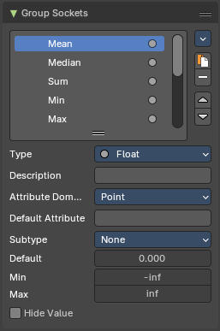
Manage the input and output properties of the Group Input and Output nodes.
More than one input and output slot can be useful when you want to modify the shader in the node group in more than one way.

Group Socket List
List of available input and output sockets.
Note: The list can be sorted by dragging the items around. And you can rename them.

List
The list of input and output sockets.

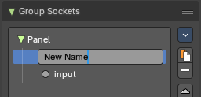
Name
Change the name of the current selected input socket by double clicking on the socket in the list. Type in a new name and hit enter.

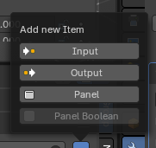
New Item
Adds a new input sockets to the list.

Input
Adds a new input sockets to the list.

Output
Adds a new output socket to the list.

Panel
Adds a new panel socket to the list.

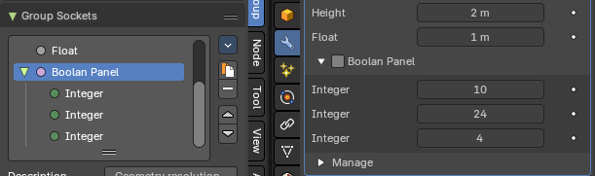
Panel Boolean
Converts an active selected Boolean socket into a Panel Boolean.
When converting a boolean to a panel boolean, the parent panel of the Boolean socket will move to the panel header.

Duplicate Item
Duplicates the active socket.

Remove Item
Removes the selected input socket from the list.

Move Item Up/Down
Moves the active item to the specified direction. You can move the active item up or down the list.
Note: You can also alternatively drag and drop the active item to re-order.

Inputs
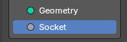
Inputs are characterized by the colored dot to the left. These are manifested in the Group Input node.

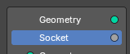
Outputs
Outputs are characterized by the colored dot to the right. These are manifested in the Group Output node.

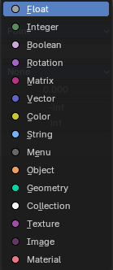
Type
What kind of node group input or output type it is.

Group Sockets Panel - Panel socket settings

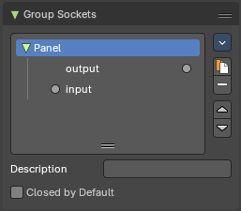

Closed by default
Panel is closed by default on new nodes.

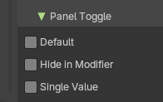
Panel Toggle
Note: The Panel Toggle properties are only for the Panel Boolean type of panels.

Default
The default value for the boolean toggles.

Hide in Modifier
Hides the panel boolean toggle from the modifier stack.

Single Value
The default value for the panel boolean toggle.

Group Sockets Panel - Input socket settings

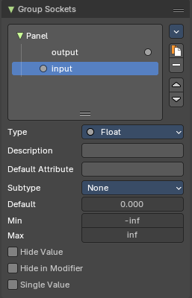
Description
Add a tooltip to the socket description.

Default Attribute
The default attribute for the socket.

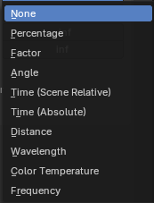
Subtype
Some node types have a subtype dropdown menu, such as the vector or float. The subtype menu allows you to define the socket type sliders and read-out.

Default
The default value for the socket.

Min
The minimum value for the socket.
Note: This is only available for vector, float and integer types.

Max
The maximum value for the socket.
Note: This is only available for vector, float and integer types.

Hide Value
Hide the input value even when the socket is not connected.

Hide in Modifier
Don't show the input value in the interface of the geometry nodes modifier.

Single Value
Only allow single value inputs instead of fields.

Group Sockets Panel - Output socket settings

Description
Add a tooltip to the socket description.

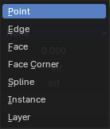
Attribute Domain
The attribute domain that is used by the geometry nodes modifier to create an attribute output.

Default Attribute
The default attribute for the socket.

Subtype
Some node types have a subtype dropdown menu, such as the vector or float. The subtype menu allows you to define the socket type sliders and read-out.

Default
The default value for the socket.

Min
The minimum value for the socket.
Note: This is only available for vector, float and integer types.

Max
The maximum value for the socket.
Note: This is only available for vector, float and integer types.

Hide Value
Hide the input value even when the socket is not connected.

